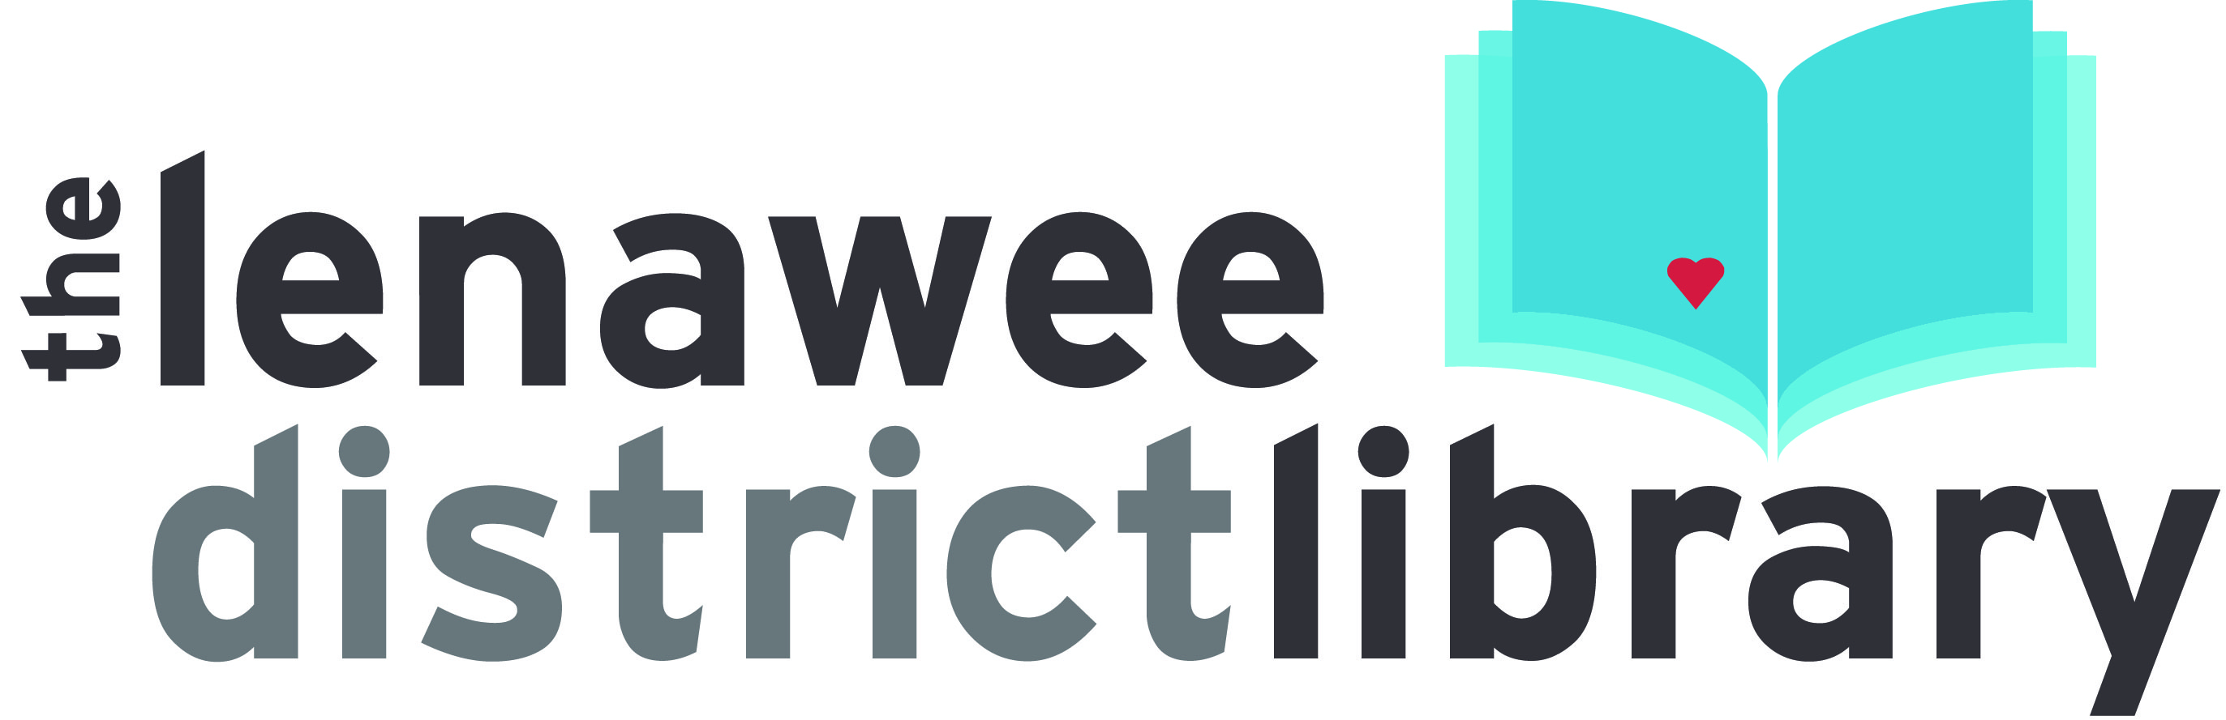

YOUTH SERVICES LIBRARIAN

GENERAL DESCRIPTION OF DUTIES

To perform professional library tasks that assist in the general operations of the library; responsibility for the youth services department in all affiliated branches; related work as required.

SUPERVISION REQUIRED

Work is performed under the guidance and supervision of the Library Director and Assistant Library Director.

SUPERVISION EXERCISED

Supervision may be exercised over other employees and volunteers as assigned to assist in various library related tasks.

TYPICAL EXAMPLES OF DUTIES

An employee of this title may be called upon to do any or all of the following:
- Communicate the importance of libraries and library materials to youth in the library community
- Perform outreach to local children or youth organizations when necessary
- Speak to civic organizations, educators, and youth-serving agencies on behalf of the children’s department to promote programs and raise awareness
- Contact and correspond with area schools, preschools, and daycare centers
- Perform reader’s advisory and reference services for library youth and teens
- Plan and execute programming in accordance with the needs and preferences of the communities served
- Help with publicity and marketing of youth programs
- Help maintain the library’s budget for youth programs and materials
- Arrange for additional funding for programming through grants, speaking to civic organizations, and visiting businesses
- Purchase books and other materials for the youth services collection as allowed by the budget
- Weed the youth services sections of the library when necessary
- Be responsible for the general organization and upkeep of the children’s area
- Present information at staff or branch staff meetings when necessary

REQUIREMENTS

EDUCATION

- Master’s Degree in Library Science from an ALA accredited program
- Library of Michigan certification
- Experience working with children
- Understanding of early childhood developmentally appropriate practice
- Strong organizational and planning skills
- Computer training and skills in Microsoft Office products (Word, Access, Excel) and a basic understanding of computer applications
- Considerable knowledge of reference materials, authors, genres, bibliographic sources, cataloging procedures, and public service procedures
- Ability to drive and a valid Michigan driver’s license

REQUIRED OF ALL LIBRARY EMPLOYEES

- The ability to lift 40 pounds
- The ability to follow oral and written instructions.
- The knowledge of computers, computer software and technology at a level sufficient to allow efficient and contemporary application of same to the necessary tasks
- The ability to stimulate an interest in reading, gathering information and using public libraries when communicating with the public
- The ability to assist the public in finding material, which requires the mobility to travel throughout the library, accompanying borrowers in their quest for information and materials
- The knowledge to instruct patrons in the use of the library, its materials, organization and equipment
- The ability to learn and understand the computerized circulation system and its capabilities in order to fully serve the public
- The ability to deal tactfully and courteously with the public and maintain good working relations with other employees
- The ability to stand for long periods of time

